**DAILY ONLINE ACTIVITIES SUMMARY**

|  |  |  |  |
| --- | --- | --- | --- |
| **Date:** | 14/06/2020 | **Name:** | Krishnitha |
| **Sem & Sec** | 4th sem, A Section | **USN:** | 4AL18CS039 |
| **Online Test Summary** | | | |
| **Subject** | NA | | |
| **Max. Marks** | NA | **Score** | NA |
| **Certification Course Summary** | | | |
| **Course** | Application Developer | | |
| **Certificate Provider** | AWS Educate | **Duration:** | 3 hrs |
| **Coding Challenges** | | | |
| **Problem Statement:**  Write a C program to remove specific characters in the String. | | | |
| **Status:** Executed | | | |
| **Uploaded the report in GitHub** | | YES | |
| **If yes Repository name** | | <https://github.com/krishnitha/C-coding> | |
| **Uploaded the report in slack** | | YES | |

**Certification Course Details:**

Today I have continued the course “Application Developer” by AWS Educate. In this course today I learnt about Software as DevOps and infrastructure as code. I have successfully completed the Second module of this course and first assessment of this course.

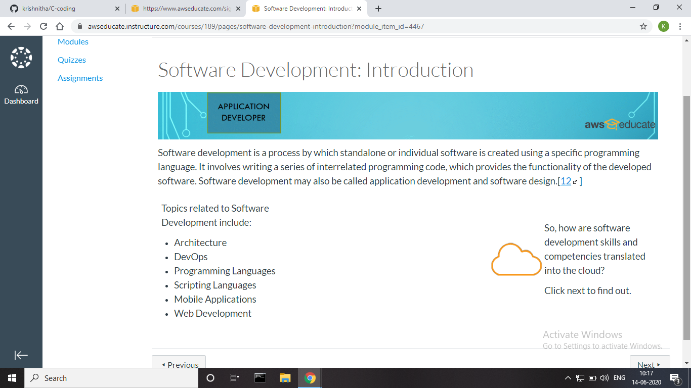



**Coding Challenges Details:**

**Problem:** Write a C program to remove specific characters in the String.

**Example**  
If the original string is "Welcome to AIET" and the user inputs string to remove "co" then the it should print "Welme to AIET" as output.

**Input**  
First line read a string  
Second line read key character to be removed.

**Output**  
String which doesn't contain key character

**Solution:** Uploaded it in GitHub

